

East West University

Department of Computer Science and Engineering

Semester : spring 2021
Course Title: Electrical Circuits
Course Code: CSE 209
Section: 03
Experiment No: 3
Experiment Title: Bias Point Detail Analysis of DC Circuit With Independent Sources Using PSpice Schematics.

Student Name: Md. Rakibur Rahman
ID: 2019-3-60-113

Date of Performance: 10-3-2021
Date of Submission: 17-3-2021

Objectives:
1. To learn fundamentals of PSpice.
2. To analyze Bias Point Detail of DC circuit using PSpice Schematics.

Circuit Diagram:
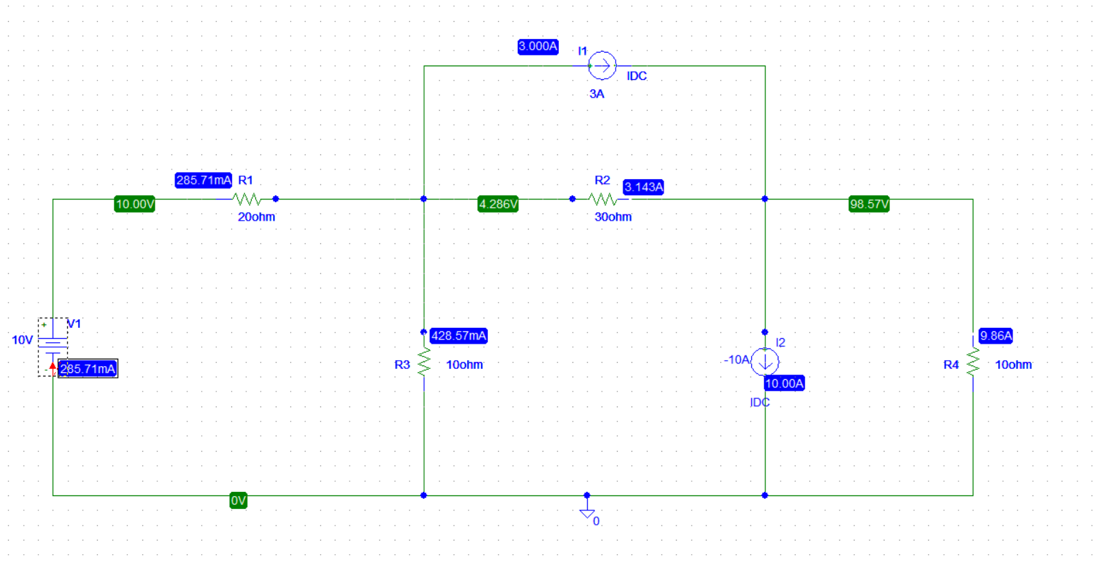

Answers to the post lab report questions:
1)
Applying KCL at node 1,
V₁=10 V
Applying KCL at node 2,
$\frac{V2-V1}{20}$ + $\frac{V2}{10}$ + $\frac{V2-V3}{30}$ = -3
$\frac{V2-10}{20}$ + $\frac{V2}{10}$ + $\frac{V2-V3}{30}$ = -3
v₂ ($\frac{1}{20}$ + $\frac{1}{10}$ +$\frac{1}{30}$ ) + v₃ (- $\frac{1}{30}$ ) = -3+$\frac{10}{20}$
.1833v₂ - .0333v₃ = -2.5 ……… (1)
Applying KCL at node 3,
$\frac{V3-V2}{30}$ + $\frac{V3}{10}$ = 3+10
v₂ (- $\frac{1}{30}$ ) + v₃ ( $\frac{1}{30}$ + $\frac{1}{10}$ ) = 13
- .0333v₂ + .1333v₃ = 13…………. (2)
Solving equation (1) and (2) we get,
v₂ = 4.272 V
v₃= 98.592 V
Calculation of the current,
R₁, I₁=$\frac{V1-V2}{20}$ =.2864 A= 286.4mA
R₂, I₂=$\frac{V3-V2}{30}$=3.144 A
R₃,I₃ =$\frac{V2}{10}$ = 0.4272 A= 427.2mA
R₄ ,I₄ =$\frac{V3}{10}$ = 9.8592A

2. Comparing the theoretically calculated values with the simulated values from PSpice.

 | Theoretical value | Obtained value
Current | I₁ =286.4 mA | I₁ =285.71mA
 | I₂= 3.144 A | I₂ =3.143A
 | I₃= 427.2 mA | I₃= 428.57mA
 | I₄= 9.8592A | I₄= 9.86A
Voltage | V₁=10V | V₁=10V
 | V₂=4.272V | V₂= 4.286V
 | V₃ =98.592V | V₃ =98.57V

The experimental values of the voltages and the currents are slightly different from the theoretical values.

Conclusion:
From this experiment we have learnt about analyzing bias point detail of a DC circuit, to calculate currents & voltages of a circuit using KCL. We have also learnt about a little discrepancy between the calculated & simulated values.

